

Strategy Maps
An Intrafocus Guide

August 2013

Table of Contents

Table of Contents 1
What is a Strategy Map? 2
How to Build a Strategy Map 3
Mission and Vision 3
Perspectives 4
Strategic Themes 5
Strategic Objectives 5
Software 7
Appendix – Sample Strategy Maps 9
Public sector example 9
Basic empty template 9
Focus on internal themes 10
With prominent mission and vision 10

What is a Strategy Map?
In 2001 Kaplan and Norton published “The Strategy Focused Organisation” which introduced the Strategy Map as an integral part of the Balanced Scorecard performance management system thus transforming it into a strategic management system.
A Strategy Map is a diagram that describes how a company or organisation can create value by linking strategic objectives in a cause and effect relationship based on the four Balanced Scorecard Perspectives: Financial, Customer, Internal Processes and Learning & Growth. The key element of the Strategy Map is that it is linked to ‘scorecards’ that monitor progress towards the Strategic Objectives. The ‘scorecards’ will include: metrics, targets for the metrics and strategic initiatives to drive performance towards achieving the metrics. An example of a generic strategy map can be seen below:
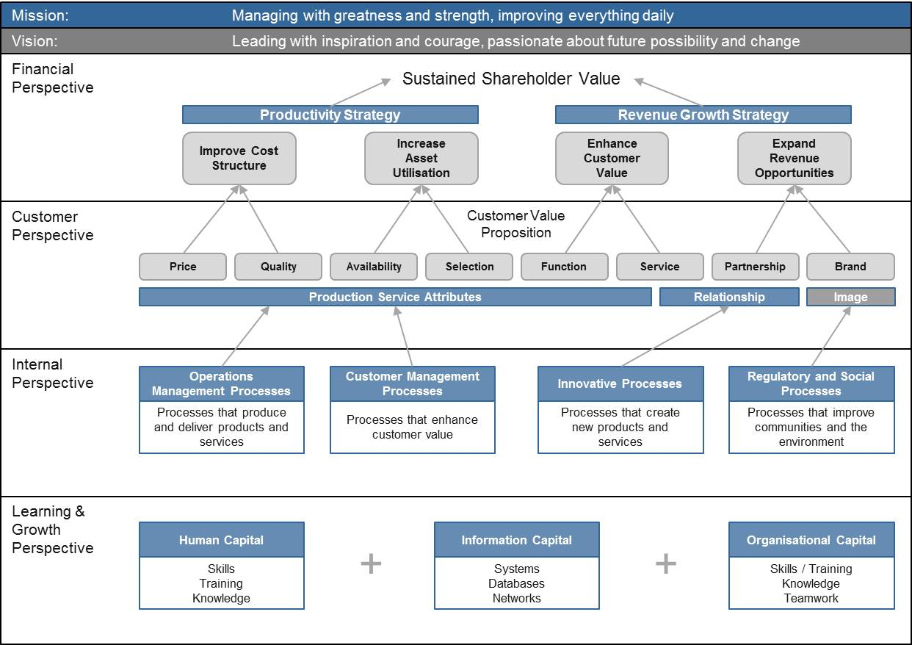
Note: editable PowerPoint templates for all of the Strategy Maps shown in this document can be found in the ‘Resources’ section of the Intrafocus website.
Clearly for the above diagram to be useful the generic needs to be specific to the company or organisation that the Strategy Map is being produced for. However, as a framework and ‘straw man’ the above is very useful. The first insight to be gained is that an entire company or organisation’s strategy can be placed on a single sheet of paper (or single screen).
This is one of the most invaluable aspects of a Strategy Map, it provides a talking point, something that the executive, management and in fact everyone in a company can look at, examine and relate to. In an instant, the means to communicate a company strategy has been created.
Overall, there are four major reasons why a Strategy Map should be created:
- It provides a clear and concise means to communicate a company strategy. Research has shown that less than 10% of employees have a clear understanding of their company’s strategy. The same research has also shown that 50% of executives spend little or no time on strategic discussion.
- It focusses attention on key strategic objectives and consequently key strategic metrics. Early use of Balanced Scorecards had a low success rate as the metrics were chosen from operational metrics already in use rather than metrics to drive strategy.
- It provides a good model for what is actually driving the strategy. With the focus on measurable objectives and strategic initiatives comes feedback on what works and what does not and therefore changes can quickly be made to reinforce the strategy.
- Clear strategic objectives drive clear strategic initiatives. At a time when budgets have to be managed carefully, the Strategy Map provides the means to identify exactly where strategic funding should be applied for the best results.

How to Build a Strategy Map

Mission and Vision
A Strategy Map cannot be created without meaningful mission and vision statements. They become the foundation of the Strategy Map; they are the over-arching statements of purpose that encapsulate the ultimate goal(s) of the company or organisation. Traditionally a ‘Mission’ describes what a company does best every day and a ‘Vision’ is what the future looks like because the mission is done so well.
For Mission think: Managing with greatness and strength, improving everything daily.
For Vision think: Leading with inspiration and courage, obsessed with future possibility
These two statements suggest that both the mission and vision should be inspiring, they should be something that everyone in a company wants to get behind and believes to be true. All too often mission and vision statements are generic and uninspiring or worse long and laborious. An example of a good mission statement comes from Nike:
- “To bring inspiration and innovation to every athlete in the World”
The Nike vision statement however leaves a lot to be desired:
- “To be the number one athletic company in the world”
Interestingly, the Nike vision statement of the 60’s was somewhat more inspiring if not a little aggressive:
- “Crush Adidas”
There are many good books on how to develop a strategic foundation including mission and vision statements. Although they may differ in methodology, without exception, all agree that the senior management team must be actively involved in the activity. This is also true of the Strategy Map. This is not an activity that should be devolved to middle management or an external consultant and then ‘signed off’ by the executive. Just as the senior executives own the strategy, they must also own the Strategy Map and discuss and agree its content.

Perspectives
The link between the Balanced Scorecard and the Strategy Map becomes immediately apparent upon the introduction of the Kaplan/Norton four perspectives. It is this ‘balance’ that has proven to be so successful in the methodology over the past decade or so. Relying on financial measures can only take a business so far, while financial measures are essential, they can only measure results, i.e. what has happened in the past. They are not predictive and therefore cannot help drive a business strategy.
The classic Balanced Scorecard includes four perspectives: Financial, Customer, Internal Processes and Learning & Growth. Strategically, for profit oriented businesses we can see that this order is important by asking a series of questions:
- What do our financial results have to be to satisfy our stakeholders?
- What must we achieve with our customers and the marketplace to successfully reach our financial results?
- What must we achieve with our internal operations for success with our customers and marketplace?
- What must our people, culture, intellectual capital and IT be to succeed with our internal operations?
In this way we can see that strategic objectives in the lower layers often (but not always) feed into the upper layers. For non-profit organisations this may not be the case, it makes sense for some non-profit organisations with fixed budgets to put the financial perspective at the bottom.
The names of the perspectives may not fit a company culture; again this is more often the case with non-profit organisations. It is perfectly acceptable to re-name the perspective or indeed to add perspectives where a specific area is of great importance to a company. In recent years the addition of an ‘Environment’ perspective has frequently been seen.

Strategic Themes
The subject of Strategic Themes is often hotly debated. We have to be very careful not to add unnecessary complexity to the Strategy Map by adding layers of non-actionable information while at the same time providing a means for all parts of an organisation to identify with and be part of the company strategy.
The focus of the Strategy Map is to highlight the vital few strategic objectives, the things that when implemented will contribute to the strategy. These objectives will almost certainly be related and therefore can be combined into strategic themes, the question is does this happen before or after the event?
The purist would argue that the strategic themes are the main, high level business strategies that form the basis for an organisation’s business model. Therefore the themes have to be defined based on the Vision and before strategic objectives are put in place. However, it is can be argued that strategic themes are by their very nature all-encompassing and vague that they actually add little value to the process of defining strategic objectives. Examples of typical strategic themes include; business growth, operational excellence, customer service, innovation, sustainability, service excellence, product development leadership and continuous improvement. As can be seen from these examples, without strategic objectives and accompanying metrics the strategic themes are all desirable and could be applied to any business. They do not however give us a clue as to what should be done specifically to improve a business.
A strategic theme does provide the means to bundle and manage strategic objectives. This can be a useful tool to limit the number of strategic objectives that appear as part of a strategy. During strategic planning sessions the desire to ‘add another project’ is always high and strategy maps often end up with thirty, forty or event fifty objectives.
It is worth noting at this point history has shown it is better to focus on a small number of things where a structure can be put in place to influence/change behaviours and outcomes rather than to spread the workload so thinly that nothing gets achieved at all. There is an old business strategy adage that states – if your strategy has 3 objectives you will succeed in all 3, if it has 4-10 objectives you will succeed in 1-2, if it contains more than 10 objectives you will succeed in none – a simple case of the law of diminishing returns.
A first cull can be made by asking the question “does this objective contribute to our Vision?” The second cull can be made by asking the question “does this objective contribute to our Strategic Theme?”.
It is down to individual preference as to whether or not strategic themes are included in a Strategy Map and if they are, should they be defined before or after the event. Whatever the choice, keep the strategic themes to a minimum, do not spend too much time on them and focus your attention on strategic objectives.

Strategic Objectives
A strategic objective must contribute to the vision and therefore the strategy. An organisation will have lots of activity being undertaken as part of its on-going operations, care must be taken avoid reflecting the operational map in the Strategy Map. Remember the Strategy Map is about fulfilling the vision; the vision is a statement of where the company/organisation wants to be in the future.
The basic rule is that the Strategy Map should contain the critical few financial and non-financial objectives, which can be measured and will deliver the success of the company/organisation. Looking at some successful company’s Strategy Maps we can see that they have kept the number of objectives low. For example, one of the UK’s largest retailers has 20 objectives, A UK high street bank has 12 and a global advertising agency has 12 as well.
Another key strength of a Strategy Map is the ability to visualise the ‘causal’ relationship between strategic objectives, that is, how one strategic objective not only influences the vision but exerts influence over another strategic objectives. Typically we find that the influence flows from the bottom of the map to the top but often it can flow from side to side and occasionally in both directions. An example of a completed strategy map with causal arrows can be seen below.
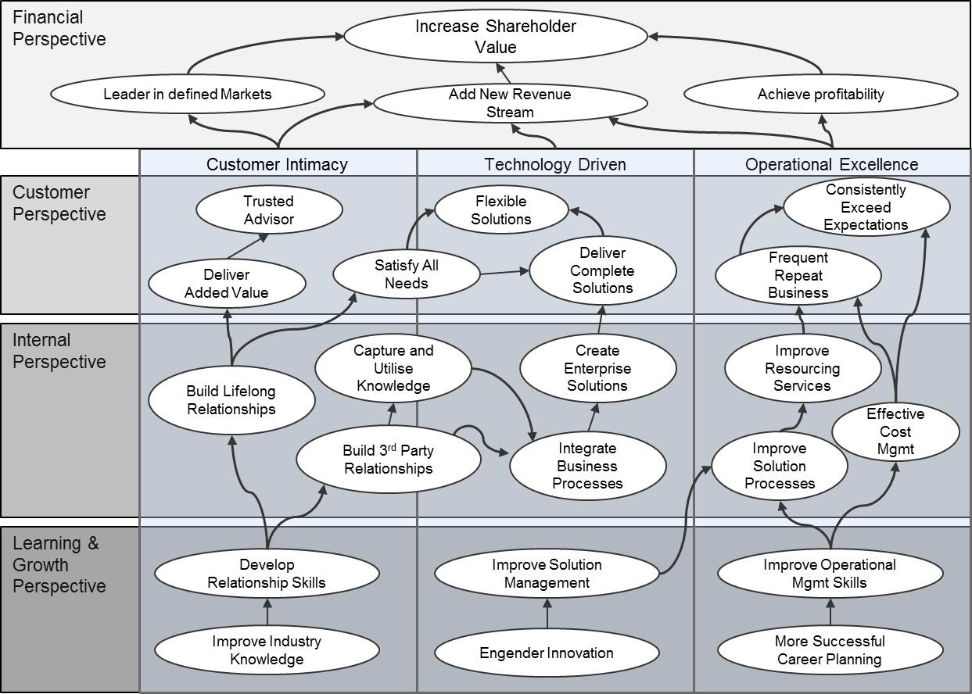
Although the Strategy map should be able to ‘stand up’ by itself, as a company/organisation communication, it is of utmost importance that each of the strategic initiatives has an associated complete description that includes:
- A full and concise description of the objective
- Exactly what is to be achieved i.e. the expected outcome
- When the objective should be complete
- How progress will be measured i.e. the associated metric(s)
- Who owns the objective and therefore associated initiative(s)
The key questions around the associated metrics and ownership will turn the Strategy Map into a living, breathing strategy rather than an academic exercise destined to the shelf until the same time next year.
It is for this reason that we strongly recommend that companies/organisations look at performance management software to help ensure the on-going management of the process

Software
The production and management of a Strategy (and a Strategy Map) can be undertaken through the normal management process of reviews and aided through the use of documents, presentations and spreadsheets. However, over the past few years several software packages have emerged that not only remove the burden of creating templates in the first place but provide the means to create Strategy Maps, collect and track metrics, collate strategic objectives, manage strategic initiatives and generate reports. Most systems also include alerting mechanisms to ensure ownership is assigned and information is kept up to date. An example of a Strategy Map created by a software product follows:
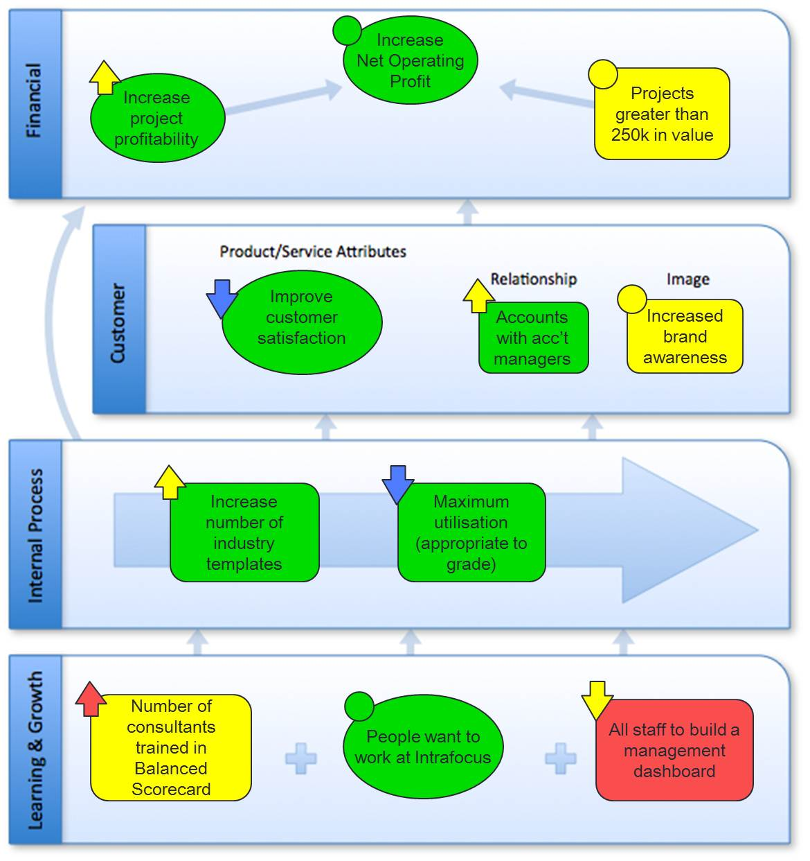
Some interesting things to note about Strategy Maps created/generated by software:
- The objectives are colour (R/A/G) coded, this status indicator will change automatically when the metrics associated with the initiatives are updated.
- There are ‘trend’ arrows which indicate the status of the objective during the previous reporting period; the software will retain a useful history.
- Each item in the Strategy Map can be ‘clicked’ on to take the viewer to the next level of information and usually all the way through to associated metrics, initiatives and reports.
The automated strategic management process can be easily integrated into existing management processes therefore keeping the ‘strategy’ alive and on the executive agenda throughout the business year.

Appendix – Sample Strategy Maps
The following examples (and more) can be found on the Intrafocus resources website

Public sector example

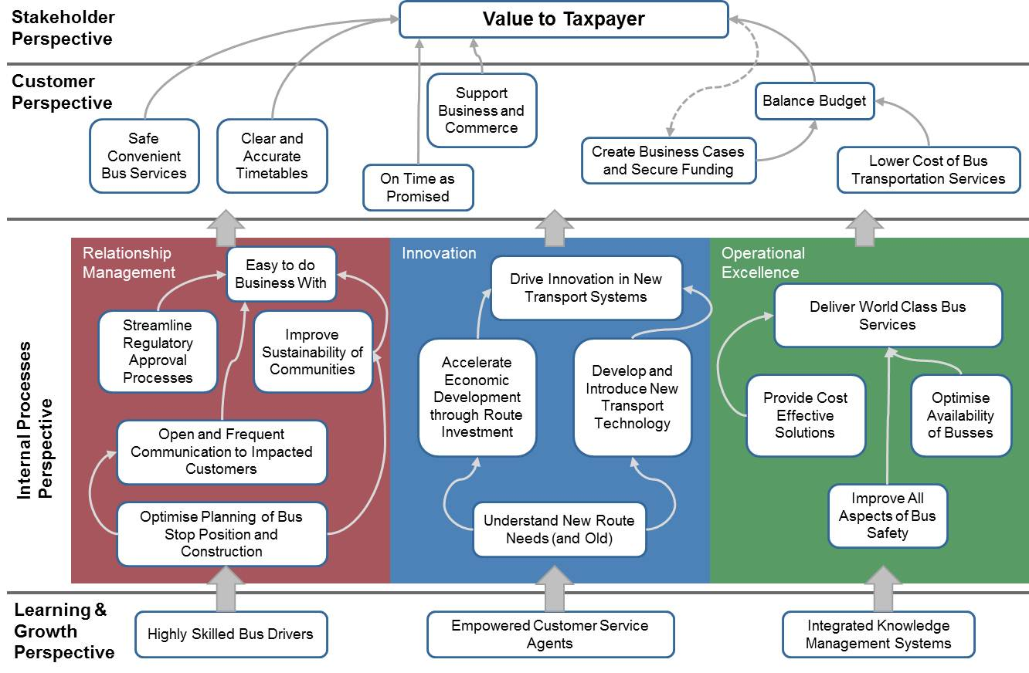

Basic empty template
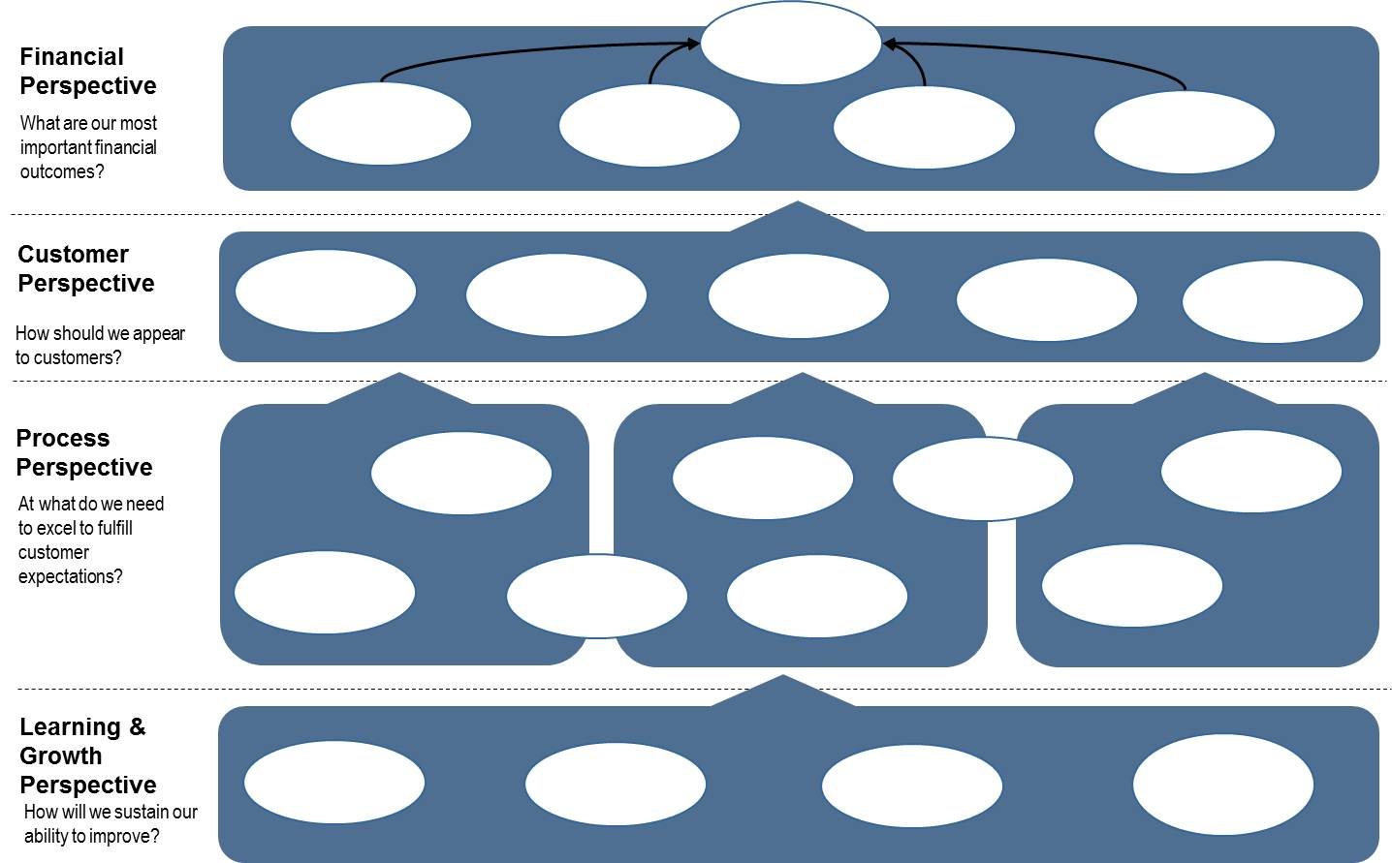

Focus on internal themes
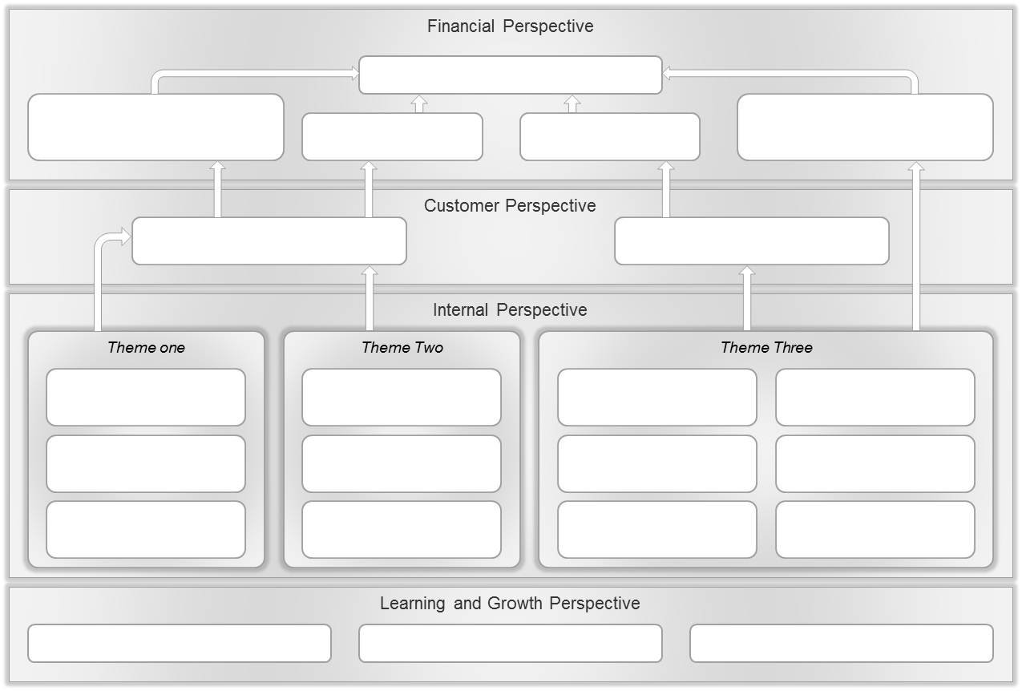

With prominent mission and vision
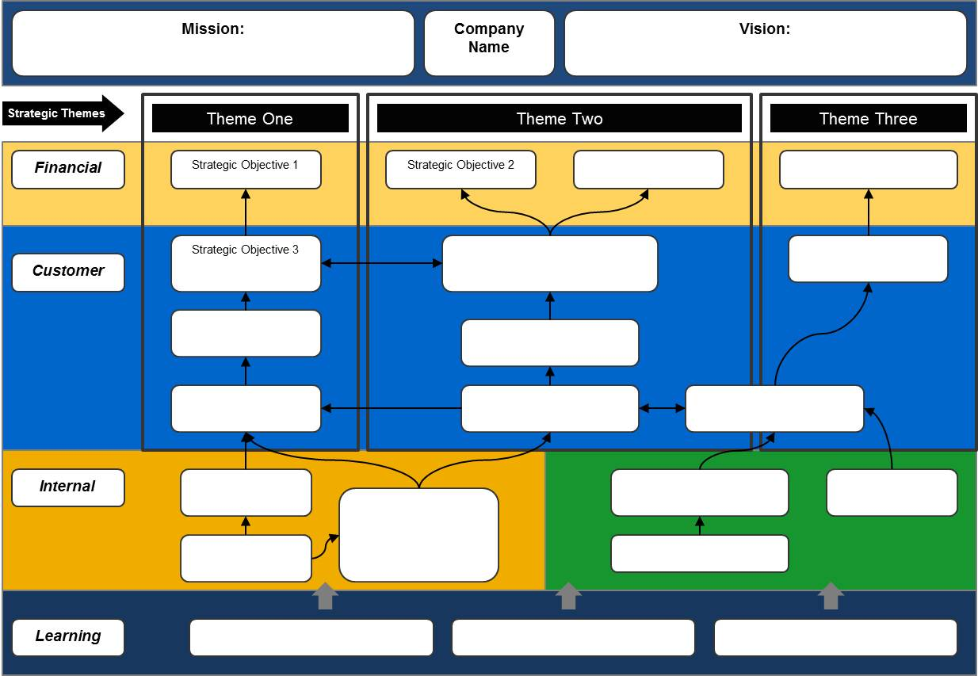

Dr Robert Kaplan and Dr David Norton are also the authors of The Balanced Scorecard – Translating Strategy into Action, Harvard Business School Press 1996
Kaplan and Norton, The Execution Premium: Linking Strategy to Operations for Competitive Advantage, Harvard Business Press, 2008

