Guide to Software Enhancements and Bug Fixes Scoreboard / QuickScore 2.10

Scorecard Templates
The latest version of the software has scorecard templates. This allows users to create multiple scorecards with the same structure. When changes are made to the source scorecard, the same changes are automatically propagated to the copies. This makes maintaining similar scorecards much easier.
To create a template scorecard, start by copying any existing scorecard.
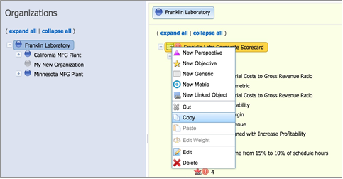
Figure 1: Copying an existing scorecard (below).

Then, go to an empty organization and paste the scorecard.
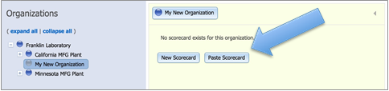
Figure 2: Pasting into a blank organization (below).

The first option is to create an independent copy of the scorecard. This is the same copy / paste functionality that was in previous versions of the software.
There is also a “Link as template” option. We’ll choose that.
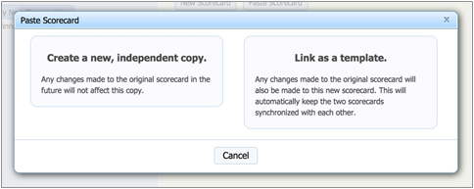
Figure 3: The two scorecard paste options (below).

This optional step allows users to append a phrase to the end of the names of all the pasted scorecard objects. A preview on the bottom shows what an example scorecard object will look like.
In this example we’re appending “(MEDCOM)” to all objects.
Figure 4: Appending a phrase to all new objects (below).
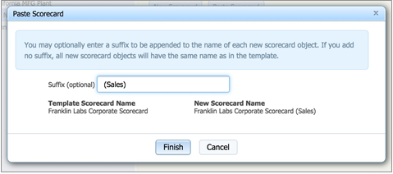

This is the newly created scorecard. On the overview screen, there is also a link back to the source template.
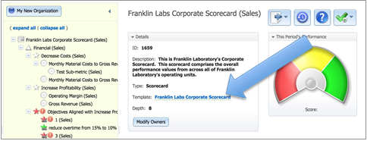
Figure 5: The completed scorecard (below).

Scorecards that are linked to a source template cannot be modified. However, it is possible to add new scorecard structure that is unique to the copy scorecard.
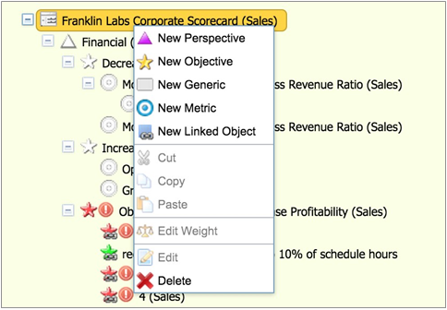
Figure 6: Cannot modify copies, can add new (below).

Dashboard Templates

The latest version of the software has dashboard templates. These are very similar to scorecard templates and allow easy maintenance of multiple similar dashboards.
This example dashboard belongs to the “Franklin Laboratory” organization. Both dashboards objects are for scorecard objects in the same Franklin Laboratory organization.
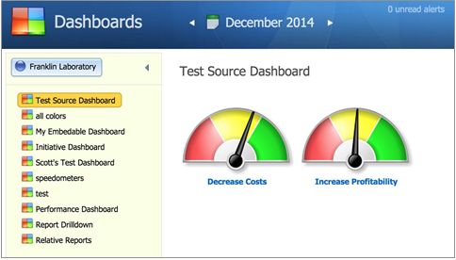
Figure 7: Source dashboard (below).

To create a template dashboard, start by copying the existing dashboard.
Figure 8: Copying the dashboard (below).
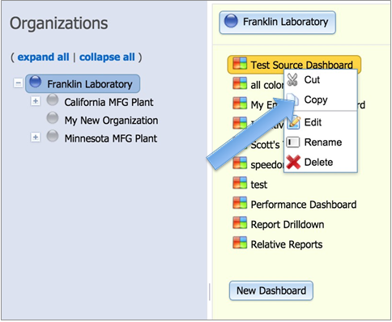

Then paste the dashboard into another organization.
In this example, we’re pasting the dashboard into the same organization that we set up with a scorecard template earlier.
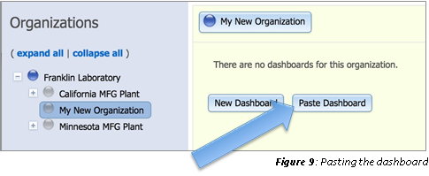
Figure 9: Pasting the dashboard (below).

As with scorecard templates, you can choose to paste an independent copy, or link as a template.
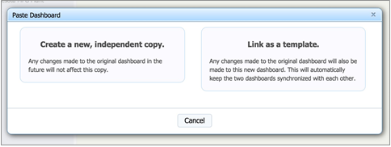
Figure 10: The two paste options (below).

After linking as a template, you can optionally choose to append a phrase to the dashboard name.
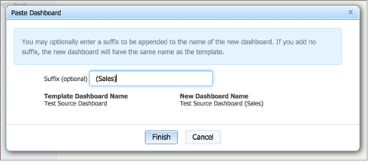
Figure 11: Optional phrase for appending (below).

This is the newly created dashboard.
Just like previous dashboard copy/paste functionality, if the source and destination scorecard structures are similar, the software will automatically remap the scorecard objects represented on the dashboard. This is especially powerful when dashboard and scorecard templates are used together.
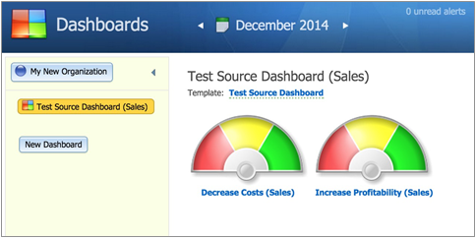
Figure 12: The completed dashboard (below).

Make Dashboard Objects the Same Size

In previous versions of the software, it was very difficult to get dashboard objects to be the same size.
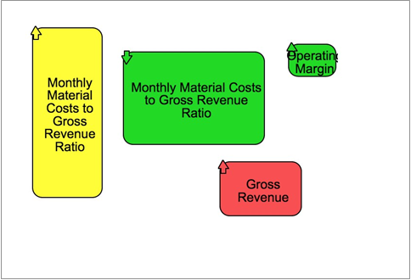
Figure 13: Dashboard objects of different sizes (below).

The new version of the software allows users to resize multiple dashboard objects at once, forcing them all to the same size in the process. To do this, select multiple dashboard objects, then drag on one of the object’s resize handles.
Figure 14: Dashboard objects of uniform size (below).
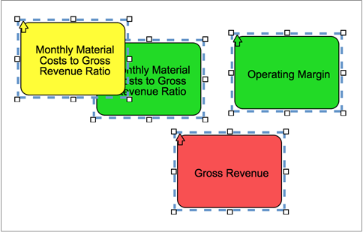

Overlapping Area Chart Series
In the new version of the software, users can now display overlapping area charts in addition to the existing stacked area chart functionality.
Figure 15: Overlapping area charts (below).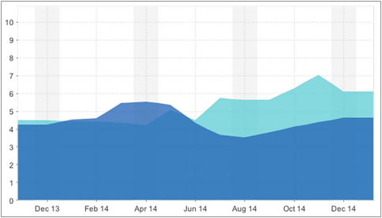

Horizontal Chart Labels

In previous versions of the software, x-­‐axis labels were displayed diagonally. This was easy to read, but it took up a large amount of space.
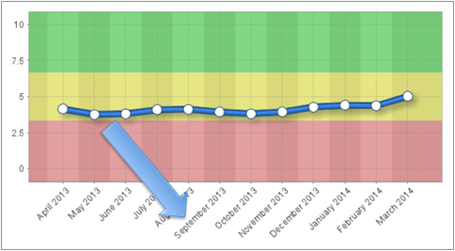
Figure 16: Diagonal labels (below).

All x-­‐axis labels are now shortened and horizontal. This frees up quite a bit of visual real estate on dashboards.
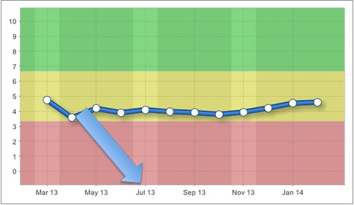
Figure 17: Horizontal labels (below).

Score and Updaters on Metrics Report

There are now checkboxes on the Scorecard Metrics screen to be able to show updaters and scores.
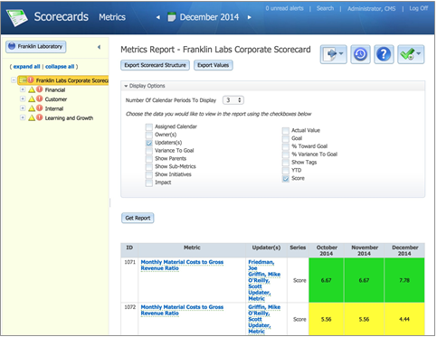
Figure 18: Updaters and Scores checkboxes (below).

Show Source Organization for Linked Objects

In previous versions of the software, it showed the source for linked objects’ Scorecard Overview screens. The source object name was often not unique, however.
In the new version of the software, the name of the source organization is now shown when hovering over the source name.
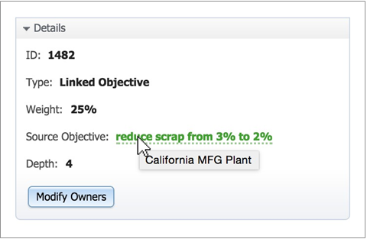
Figure 19: Showing organization on mouse-­‐over (below).

Major Expenditures on Initiatives Overview Screen

The Initiatives Overview now shows major expenditures if they exist.
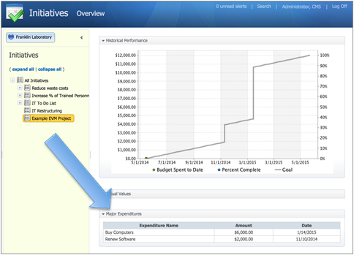
Figure 20: Major expenditures (below).

Confirm Delete of Dashboard Objects

In previous versions of the software, the delete button was easy to accidentally click.
In the new version of the software, there is now a simple delete confirmation. This greatly reduces the chances of users accidentally deleting dashboard objects.
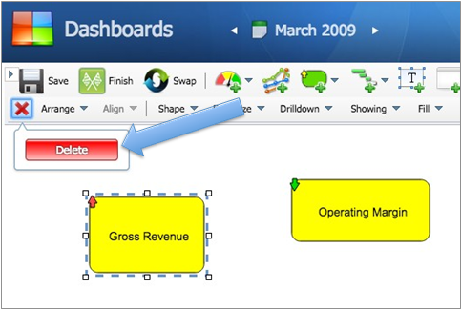
Figure 21: The new delete confirmation (below).

Other Notable Software Enhancements

• Improve search results
• Add support for averages to the TD() function in metric equations
• When building reports, default the filters to the current organization
• Remove link cursor when there's no dashboard drilldown
• Alphabetize briefing book names
• Improve alerts notification on top of screen
• Make history records show up for all periods

Notable Bug Fixes

• Dashboard objects scatter after CTRL selection
• Stickiness when resizing text dashboard objects inward
• Dashboard text objects sticky when moving quickly
• Dashboard text objects prone to sticking when canvas is scrolled
• Trigonometric functions in metric equations don't work with metric IDs
• Relative periods off by one for embedded dashboards
• Can't drag and drop scorecard rapidly
• Tags report writer filter operator is an "OR" rather than an "AND"
• Uncheck all doesn't uncheck Metric Values checkboxes when thresholds also checked
• Scorecard builder doesn't display 'Higher is worse' option
• Analyze and tune top SQL
• Delete scorecard objects are not audited
• Mass edit change of scorecard object name isn't audited
• Equations unable to handle TD() in nested functions for metric equations
• Initiatives with past due date don't turn red
• Past due action with a budget is "On schedule" when missing % complete
• Red metric indicator displays for archived red metrics
• Misc. speed improvements

