Guide to Software Enhancements Scoreboard / QuickScore 2.9

Redesigned Initiatives Overview

In the latest version of the software, the Initiatives section now supports Earned Value Management (EVM) projects.

Based on the EVM methodology, users regularly update how much has been spent on a project and what percent complete it is. The software then shows a graph tracking their progress and projects both budget and schedule to determine how the project is performing.

Even if the EVM methodology isn’t strictly followed, the redesigned Initiatives Overview screen is much easier to use than previous versions of the software.

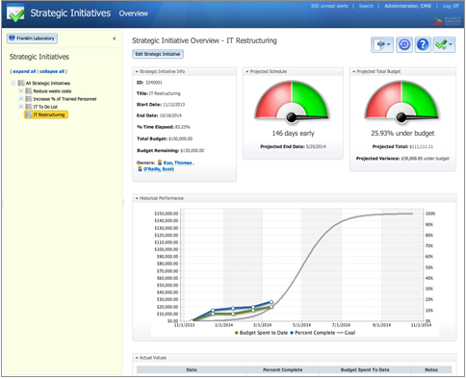
Figure 1: An EVM project (below).

Initiatives in Calculated Metric Equations

Initiatives and Tasks can now be used in metric equations, further integrating the Scorecards and Initiatives sections of the software. The following values are available:

• Percent Time Elapsed
• Percent Complete
• Projected Schedule Variance (in days, positive for early)
• Total Budget
• Budget Spent to Date
• Budget Remaining
• Projected Total Budget
• Projected Budget Variance (positive for under budget)
• Projected Budget Variance Percentage (positive for under budget)

Faster Calendar Period Switching

There are now forward and backward arrows for calendar periods in the header. Using these is much faster than having to open the entire calendar selector.
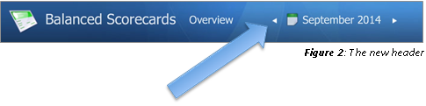
Figure 2: The New header (below).

New Display Options for Dashboard Objects

In the latest version of the software, users can change many more display options for dashboard objects.
For example, this is what a note looks like when you add it to a dashboard. In previous versions of the software you couldn’t turn off any of the display options like Title, Controls, Author, Replies, Scorecard Node, Period, Created, or Last Updated.
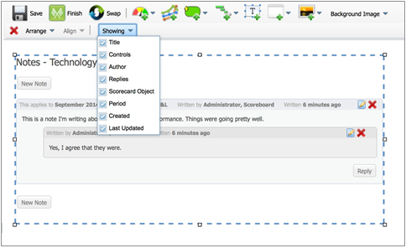
Figure 3: All notes options turned on (below).

This is what it looks like with everything turned off except for the Calendar Period.
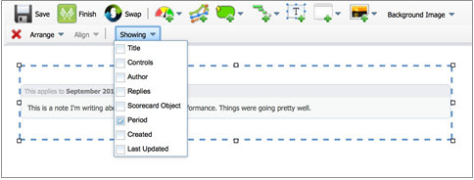
Figure 4: Only calendar period turned on (below).

Reports also have a “Showing” menu now. This is the default appearance, which was the only option before.
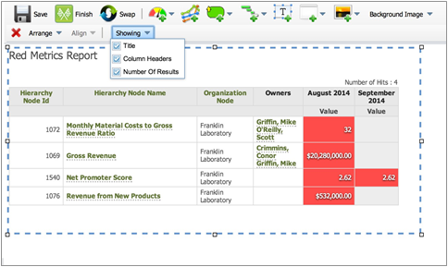
Figure 5: All reports options turned on (below).

You can now turn off the Title, Column Headers, and Number of Results.
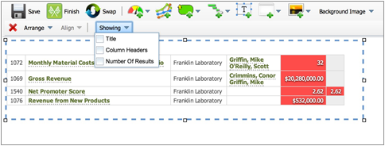
Figure 6: All reports options turned off (below).

Dashboard bubbles had a “Showing” menu before, but in the latest version of the software, there are new options. You can now choose to see a scorecard node’s Score and Weight.
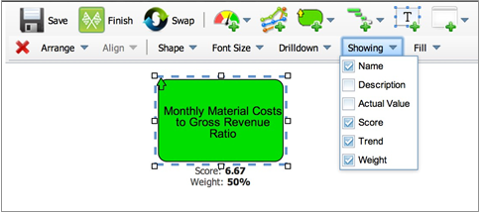
Figure 7: Score and Weight for bubbles (below).

Reports now have the “Showing” menu too. This is what charts always looked like in previous versions of the software.
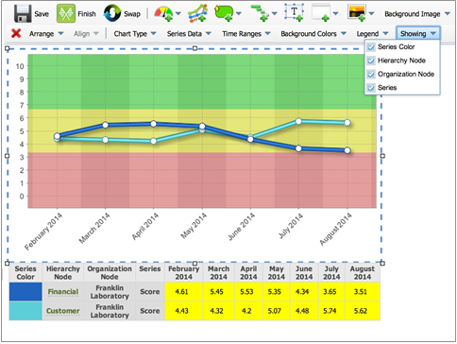
Figure 8: All chart options turned on (below).

You can now turn off Series Color, Scorecard Node, Organization Node, and Series. In this example, the Organization Node and Series aren’t needed, so they’re turned off.
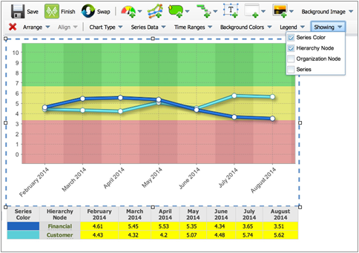
Figure 9: Only some chart options turned on (below).

Dashboard Notes Stay Within Containing Box

When users add notes to a dashboard, they choose how large to make the notes box. In previous versions of the software, if there was too much content to fit inside the box, it would overflow outside of the box on the bottom.
If there was content underneath the notes box, however, this was a problem. As you can see here, it would overlap with existing content.
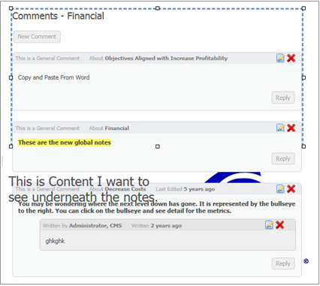
Figure 10: Notes overflowing the bottom (below).

In the new version of the software, notes stay within their box. If there is too much content to fit, the software adds scrollbars.
If users would prefer to see very tall notes rather than scrollbars, they can just make their notes boxes very tall to give their notes room to grow.
Figure 11: Notes not overflowing with scrollbar (below).
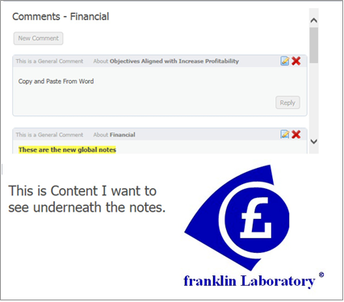

Drilldown Links in Embedded Reports

When users embed a report in a dashboard, the names of the scorecard nodes are now clickable. This takes you to the scorecard overview screen for more information.
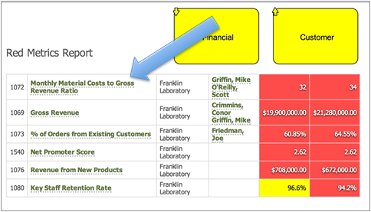
Figure 12: Drilldown links in an embedded report (below).

Drilldown Target of “None” on Dashboards
There is a new drilldown target option on dashboards called “none”. This lets users choose to show an object on the dashboard but not make it clickable.
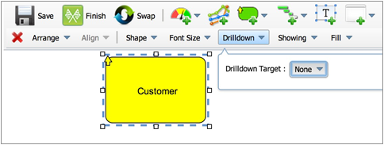
Figure 13: Drilldown target of “none” (below).

New “Current Calendar” Option for Charts
In previous versions of the software, users had to choose a calendar like Monthly or Yearly when building a chart in the Reports section.
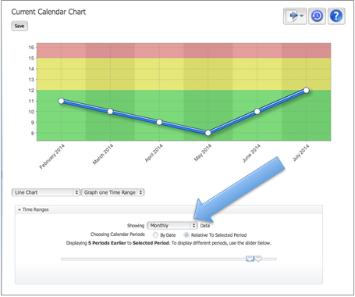
Figure 14: Chart Writer used to require a specific calendar (below).

The default chart calendar in the software is now a new option called “Current Calendar”. Users can still choose to use a specific calendar like monthly or Yearly, but only if they choose to.
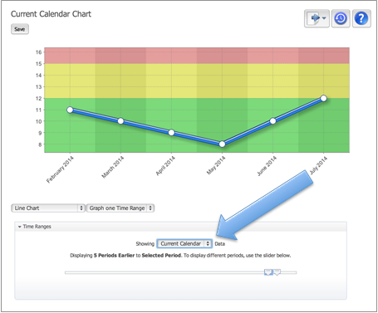
Figure 15: The new Current Calendar option (below).

When a chart is created with “Current Calendar” selected for the calendar, the chart then shows data for the calendar shown in the calendar period selector in the header.
In this example, the calendar period selector has been changed to yearly and the example chart is showing yearly data instead of monthly.
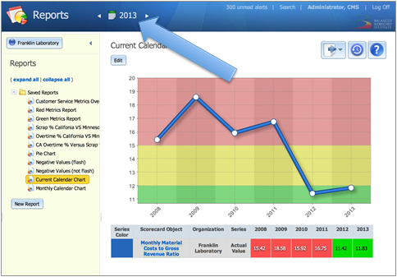
Figure 16: Changing to Yearly changes the chart calendar also (below).

“Current Calendar” Option for Embedded Charts in Dashboards

When users embed charts from the Reports section into dashboards, the new default calendar is now a new option called “Current Calendar”. This means the chart will show data for the same calendar as in the main calendar period selector.
Users can continue to override the new default and force the chart to be for a particular calendar.

Improved “Send to Briefing Book”

Adding a page to a Briefing Book used to be confusing in older versions of the software. The software would show dropdowns that weren’t relevant to the currently selected option.
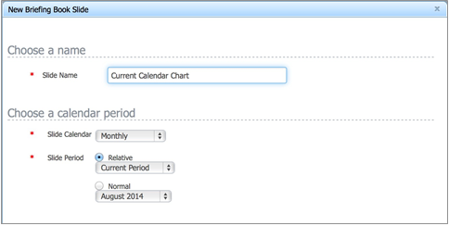
Figure 18: The old “send to briefing book” dialog (below).

In the new version of the software, the software only shows dropdowns if they are required for the currently selected option.
In this example “Relative” is selected for the calendar period, so only the relative calendar period dropdown is shown.
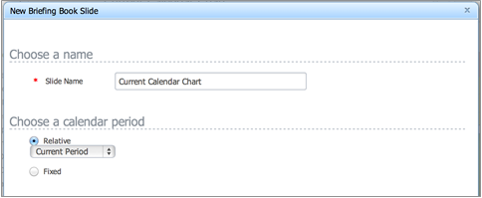
Figure 19: The new “send to briefing book” dialog (below).

Thinner Lines on Charts
In previous versions of the software, the lines in charts were very thick when only one series was being graphed.
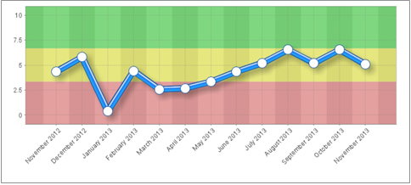
Figure 20: The old thicker line (below).

The lines in charts are now narrower. This makes charts easier to read by drawing attention to smaller value changes.
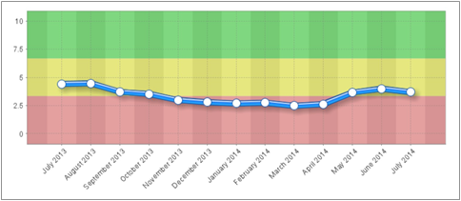
Figure 21: The new thinner line (below).

Show Group Administrators on User Form
In previous versions of the software, it listed all of a user’s group memberships, but not the groups for which they had administrator permission. It now lists both.
If the user is both a member of a group and an administrator, it will list them twice for that group as shown in this example.
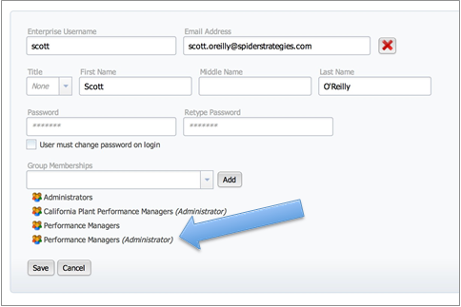
Figure 22: Group administrators listed on the user form (below).

New Search and Replace Options

There are three new search and replace options when editing multiple scorecard nodes in Report Writer.
The first is append to the end.
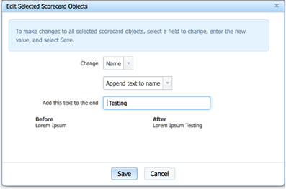
Figure 23: Append to existing (below).

The second is prepend to the beginning.
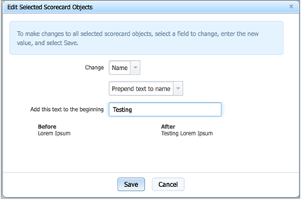
Figure 24: Prepend to existing (below).

The third is wildcard replace. For example, replace everything starting with '(' and ending with ')'.
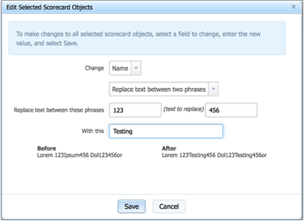
Figure 25: Replace between (below).

Other Notable Software Enhancements

• Add the ability to embed multiple dashboards on the same webpage.
• All dashboard bubbles now have no outline when a fill of “none” is chosen.
• Show target name on hover for dashboard objects that link to other dashboards.
• Dramatically improve the speed dashboards are displayed by reducing the number of server responses.
• Dramatically improve the speed of organization deletes.
• Improve performance of the organization tree, especially the "expand all" function.
• Remove the delay after dragging a scorecard object to a new position.
• Sort calendars by display order for report writer charts embedded in dashboards.
• Increase the Metrics Report's max period display from 18 to 24
• Improve IE11 compatibility.
• Slow down the refresh rate of the current user activity screen.
• Write audit records to the database for calendar and calendar period creation, editing, and deleting.
• Indent structure on Initiatives > Tasks screen.
• Allow multiple updates to happen simultaneously, avoiding "the operation could not be completed..."
• Make instant alerts a plain text box instead of rich text editor, since the alerts are actually sent out as plain text.
• Reload configuration changes immediately.
• Disable organization and scorecard tree reordering from iOS.
• Create restful endpoint for dash to gather app and server stats

