Linking an Initiative/Task to a Metric (or Objective)

In this scenario we examine what might happen when a metric has moved into the RED and an explanation of the cause is required followed by a remedial action.
During a monthly review, it has been noted that the objective, Increase Large Project Sales, has gone into the red:
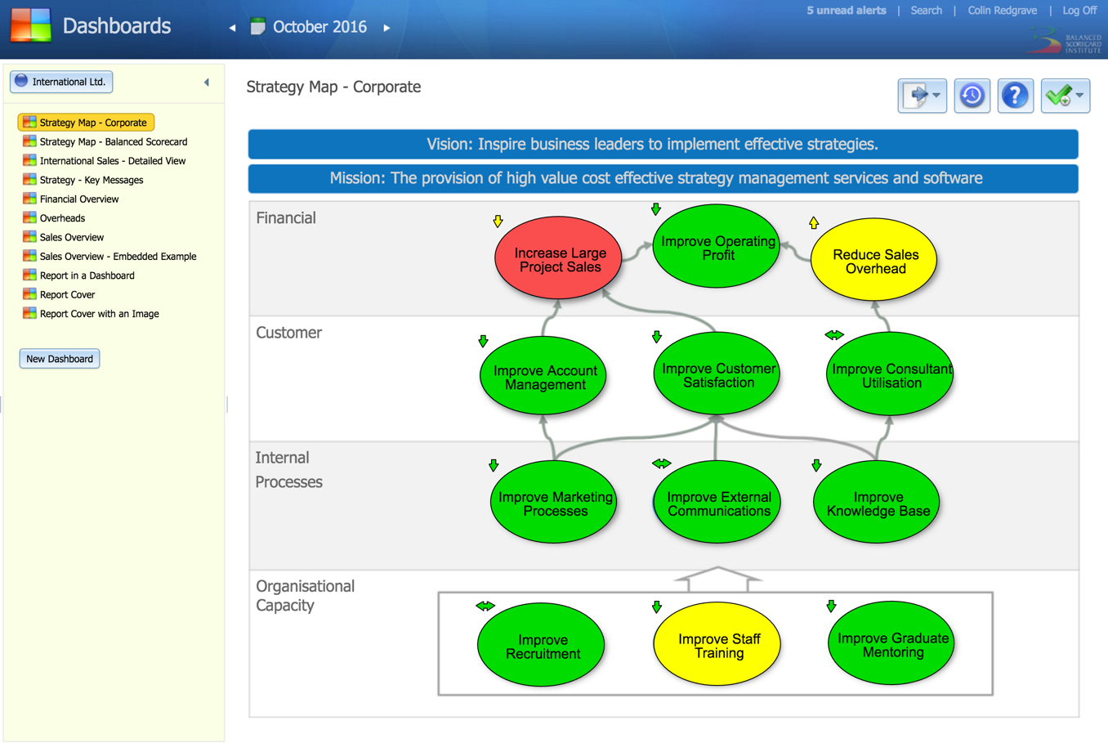

By clicking on the strategy map bubble the application takes us into Scorecards and directly to the Increase Large Project Sales objective. Here we can see the objective has two measures; Commercial Sales, which is green and Projects Greater than £25k which is red. If we click on the Projects Greater Than £25k metric we will see the following:
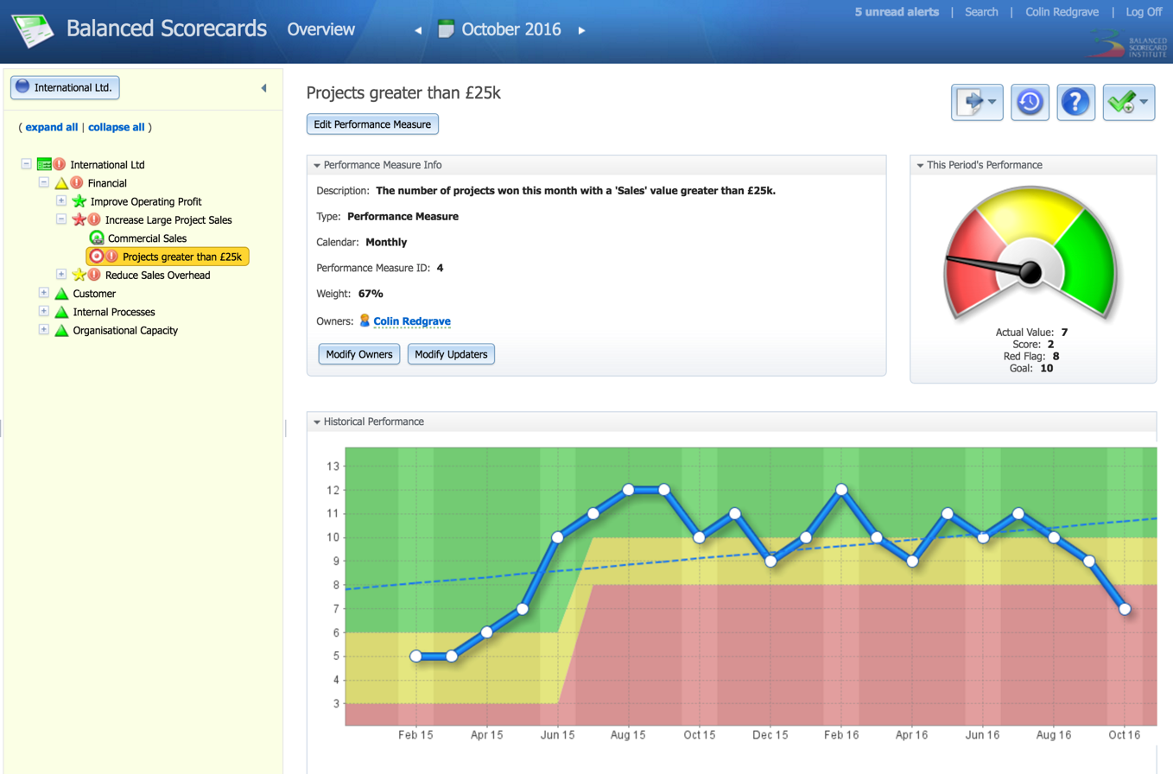
Immediately we can see that there is a problem that has been in the making for the past three months. It is reasonable to assume at this stage that this is not an anomaly and an explanation is required. By scrolling down, we find a note has been added by the metric owner:
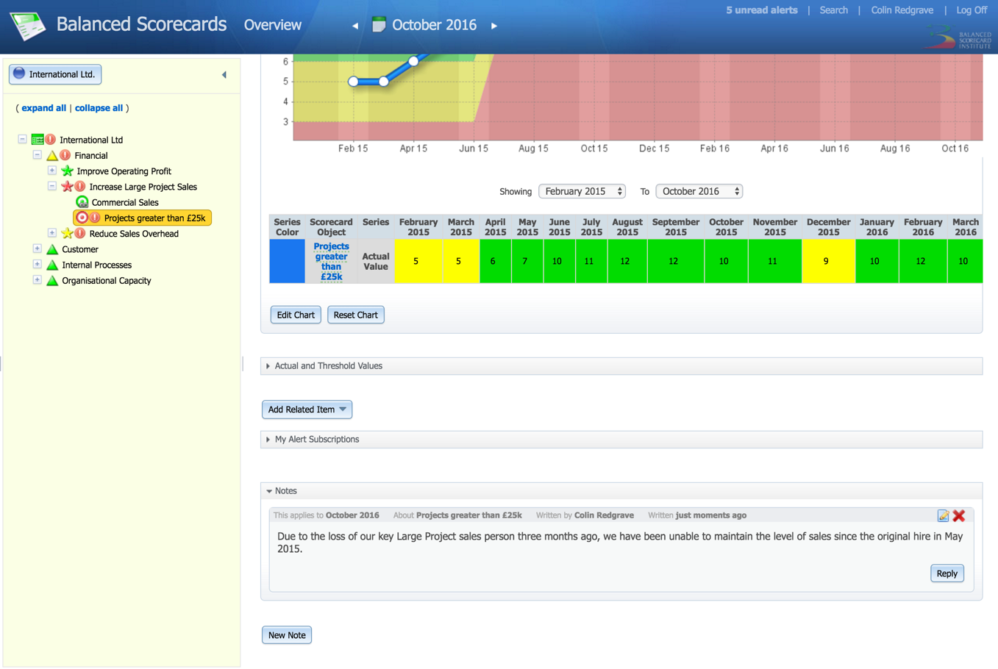
A decision is taken to put in place remedial action. In his case to hire a new Large Project sales person. As this is deemed a strategic action, the activity is going to be tracked within the system.
By clicking on the New Task button at the top of the screen, we are given the option to create a new Strategic Initiative, Task or Milestone.
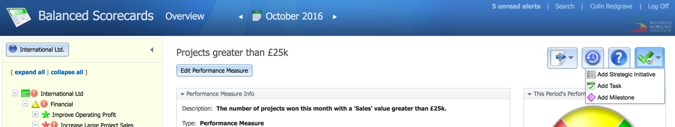

In this case we will select Strategic Initiative. A dialogue box appears into which we can add details of the initiative, timescales and an owner.
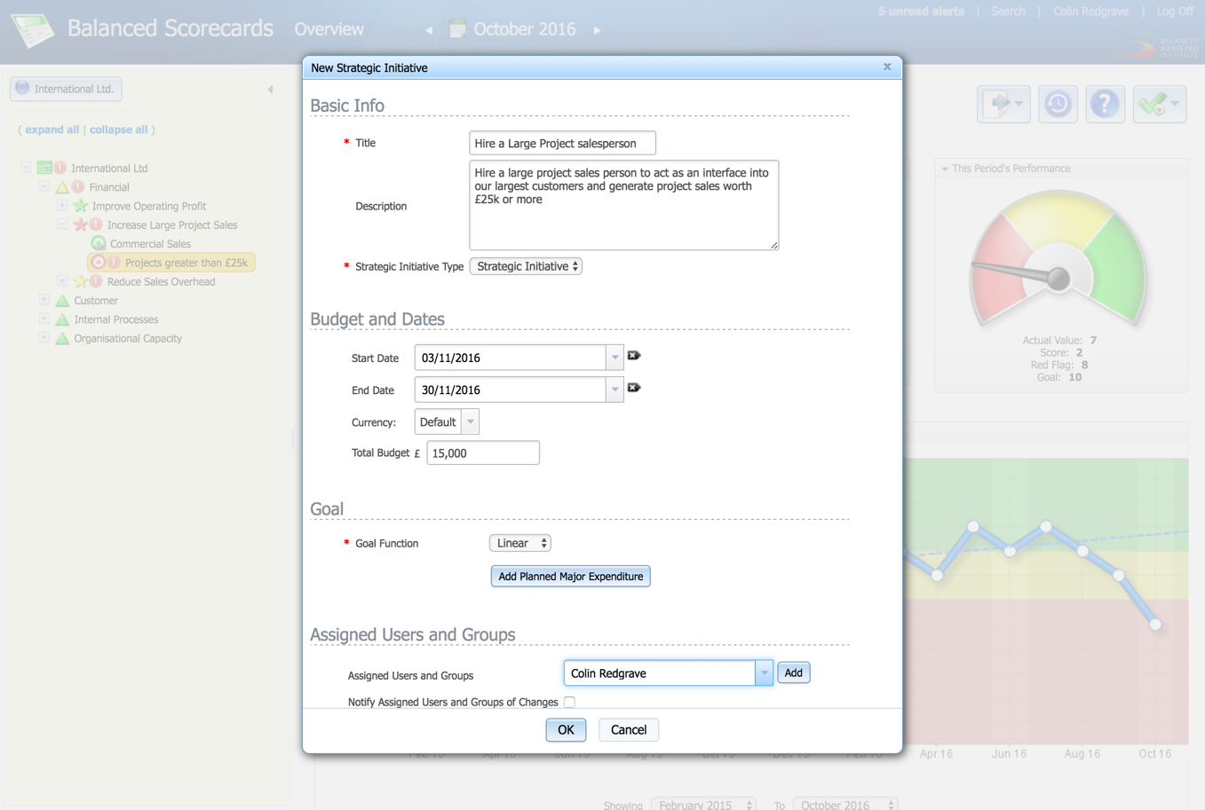
Once assigned, the owner of the strategic initiative will be notified and the base information can be found as a Related Item to the Metric.
The Initiative owner can then update the Initiative and add tasks and milestones if required. In this case the Initiative is relatively simple and might end up looking something like this:
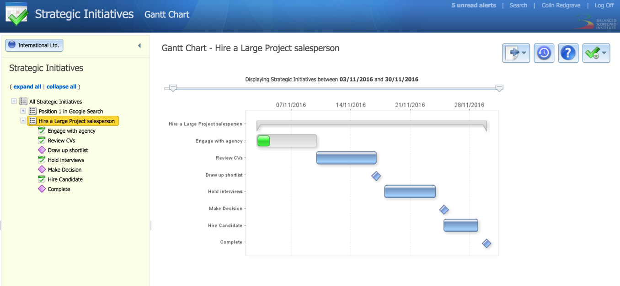

By clicking on the sub-menu and selecting Related Items:
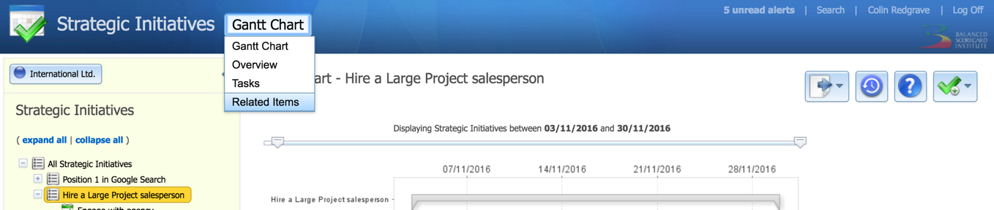

the loop back to the original Metric can be found:
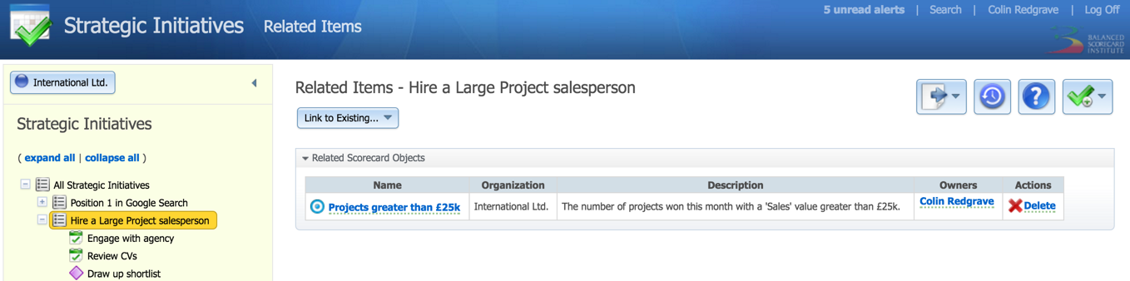

Related Initiatives and Tasks can be added to Metrics (KPIs), Objectives, Perspectives and Scorecards.

